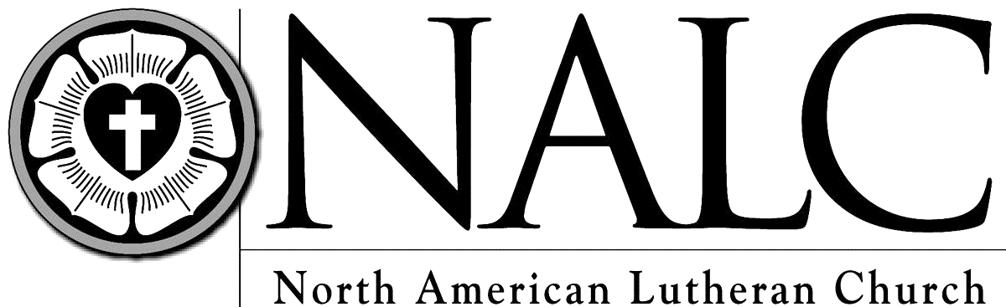
WOV - With One Voice
CH - Celebration Hymnal
LBW - Lutheran Book of Worship

EMMANUEL LUTHERAN CHURCH
PO Box 282 308 4th Avenue Grafton, Iowa 50440
Office: 641-748-2736 Parsonage: 641-748-2050
emanluthch@wctatel.net PastorZ@wctatel.net www.emmanuelgrafton.org
Pastor: Solveig A.H. Zamzow Organist: Marena Henkle
Lay reader: Suzanne Seleskie Acolyte: Kaelee Hicken
9th Sunday of Pentecost
August 11th, 2019

Prelude
P: The grace of our Lord Jesus Christ, the love of God, and the communion of the Holy Spirit be with you all. C: And also with you.
The Gathering Song: God, Who Stretched the Spangled Heavens LBW # 463
P: You are the treasured people of the Lord C: a people holy to the Lord our God.
P: Keep the words of the Lord in your hearts; teach them to your children.
C: Talk about them when you are at home and when you are away, when you lie down and when you rise.
P: One does not live by bread alone
C: But by every word that comes from the mouth of the Lord.
Prayer of the Day: Almighty and Everlasting God, you are always more ready to hear than we are to pray, and to give more than we either desire or deserve. Pour upon us the abundance of your mercy, forgiving us those things of which our conscience is afraid, and giving us those good things for which we are not worthy to ask, except through the merit of your Son, Jesus Christ our Lord. Amen
The First Lesson: Genesis 15:1-6
Psalm 33:12-22 (Read responsively by full verses) LBW p. 231
The Second Lesson: Hebrews 11:1-3, 8-16
The Gospel Acclamation: Halle, Halle, Hallelujah WOV # 612
The Holy Gospel: Luke 12:32-40
The Sermon
Sermon Hymn: Many and Great, O God, Are Your Works WOV # 794
The Apostles’ Creed WOV p. 19
The Collection of the Offering
The Offertory: For the Fruit of All Creation (verse 1) WOV # 760
The Prayer of the Church
The Lord’s Prayer
The Blessing
Announcements
The Closing Hymn: Have No Fear, Little Flock LBW # 476
Chimes and Postlude
Members, friends and visitors: welcome to our worship today. We are glad you are here and your presence is important to all of us. If you are able, join us in the Fellowship Hall for light refreshments and conversation.
This evening is the start of Emmanuel’s VBS. A light supper is served at 5:30pm and fun to follow!
Come celebrate with Dale Schultz his 80th birthday on August 18th during fellowship. Cards only, please. Dale Schultz, Room 55, 701 9th St. N, Northwood, IA 50459
School Supplies Needed for Kits- 70 sheet- Wide or college ruled Notebooks, Ball Point Pens (no gel ink), Rulers, Pencil Sharpeners, Crayons, #2 pencils and Scissors. If you would like to donate supplies or money towards school supplies please contact Clarice Bartz.
Erna Pagel Grant applications are due on August 31st and applicants must fill out new application each year. Please turn in to Lisa Bartz or the Church Office.
The deadline to sign up for the All women’s painting and stenciling event is Monday, August 26th. The event will take place at Valerie Foss’s Painted Horse Studio on Thursday, September 5th at 7pm. You may drive yourself or we will gather at 6:45pm at Emmanuel and car pool. The outing will cost approximately $40 per person. We hope to see you there!
Ice Cream Social at Bethlehem in Manly, next Sunday, August 18th from 4-6:30 pm.

This Week at Emmanuel August 12th – 18th
Monday, August 12 | 5:30 pm | Vacation Bible School
Tuesday, August 13 | 5:30 pm | Vacation Bible School
Wednesday, August 14 | 7:00 pm | Council Meeting
Friday, August 16 | 5:30 pm | Rehearsal Dinner
Saturday, August 17 | 4:00 pm | Rustad / Dunn Wedding
Sunday, August 18 | 9:30 am | Worship
 | 10:30 am | Fellowship

August 4th – Attendance: 73
Offering: General: $2,205, Benevolence: $20, Building: $20, Food Bank: $30

