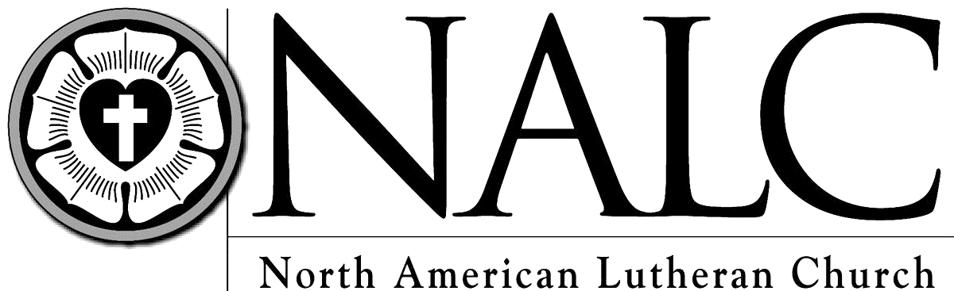
WOV - With One Voice
CH - Celebration Hymnal
LBW - Lutheran Book of Worship

EMMANUEL LUTHERAN CHURCH
PO Box 282 308 4th Avenue Grafton, Iowa 50440
Office: 641-748-2736 Parsonage: 641-748-2050
emanluthch@wctatel.net PastorZ@wctatel.net www.emmanuelgrafton.org
Pastor: Solveig A.H. Zamzow Organist: Charlotte Cole
Lay reader: Acolyte: Brooklyn Hackbart
9th Sunday of Pentecost
August 18th, 2019

Prelude
P: The grace of our Lord Jesus Christ, the love of God, and the communion of the Holy Spirit be with you all. C: And also with you.
The Gathering Song: Oh, for a Thousand Tongues to Sing LBW # 559
P: You are the treasured people of the Lord C: a people holy to the Lord our God.
P: Keep the words of the Lord in your hearts; teach them to your children.
C: Talk about them when you are at home and when you are away, when you lie down and when you rise.
P: One does not live by bread alone
C: But by every word that comes from the mouth of the Lord.
Prayer of the Day: Almighty and ever-living God, you have given great and precious promises to those who believe. Grant us the perfect faith which overcomes all doubts, through your Son, Jesus Christ our Lord. Amen
The First Lesson: Jeremiah 23:23-29
Psalm 82 (Read responsively by full verses) LBW p. 253
The Second Lesson: Hebrews 11:29-12:2
The Gospel Acclamation: Halle, Halle, Hallelujah WOV # 612
The Holy Gospel: Luke 12:49-56
The Sermon
Sermon Hymn: Faith of our Fathers LBW # 500
The Apostles’ Creed WOV p. 19
The Collection of the Offering
The Offertory: For the Fruit of All Creation (verse 1) WOV # 760
The Prayer of the Church
The Lord’s Prayer
The Blessing
Announcements
The Closing Hymn: Lead on Oh King Eternal LBW # 495
Chimes and Postlude
Members, friends and visitors: welcome to our worship today. We are glad you are here and your presence is important to all of us. If you are able, join us in the Fellowship Hall for light refreshments and conversation.
The altar flowers are given in celebration of Dale Schultz’s 80th birthday by his family. Please join Dale in the Fellowship Hall for a time of conversation and fellowship. Cards only, please. Dale Schultz, Room 55, 701 9th St. N, Northwood, IA 50459.
A sincere word of gratitude to all teachers and helpers who made our VBS possible and successful. We had 20 students in attendance.
School Supplies Needed for Kits- Erasers, Ball Point Pens (no gel ink), Rulers, Pencil Sharpeners, Crayons, #2 pencils and Scissors. If you would like to donate supplies or money towards school supplies please contact Clarice Bartz.
Erna Pagel Grant applications are due on August 31st and applicants must fill out new application each year. Please turn in to Lisa Bartz or the Church Office.
The deadline to sign up for the All women’s painting and stenciling event is Monday, August 26th. The event will take place at Valerie Foss’s Painted Horse Studio on Thursday, September 5th at 7pm. You may drive yourself or we will gather at 6:45pm at Emmanuel and car pool. The outing will cost approximately $40 per person. We hope to see you there!
Ice Cream Social at Bethlehem in Manly, today from 4-6:30 pm.
Campfire Service at St. John’s Lutheran on Saturday, August 24 with a meal served at 5:30 pm and the service to start at 6:15 pm.

This Week at Emmanuel August 19th – 25th
Sunday, August 25th | 9:30 am | Worship
 | 10:30 am | Fellowship

August 11th – Attendance: 68
Offering- General: $1,411, Building: $20

